Philmont Simplifies Trek Planning for 2025
PTC Celebrates 75 Years in 2024

Philmont! The word itself evokes excitement in Scouts and Scouters, and in the coming year there is a lot to be excited about.
On October 16, the new Trek Registration process for 2025 starts. Now every unit that applies for a Philmont Expedition in 2025 will get a slot. Units can now plan with certainty that their High Adventure plans at Philmont will be a reality. For those Crews still thinking about Trekking in the coming summer of 2024, there are still openings available. Check out www.philmontscoutranch.org for information.
The coming summer of 2024 will mark the 75th year of Philmont Training Center. The year’s schedule of exciting conferences and fun-filled Family Adventure Camp opportunities is already out. www.philmontscoutranch.org/ptc/ Registration for classes will open in November. If you are thinking about a conference, remember to bring your family along! PTC now offers deluxe tent accommodations as well as roofed housing.
If you just happen to be travelling through the great Southwest and just want to spend a few days at Philmont, you can now do so! PTC now offers daily accommodations www.campspot.com/book/philmontscoutranch that will give you time tour to its historic sites at Rayado, Villa Philmonte, and Chase Ranch and pick up a few souvenirs at the Tooth of Time Traders.
For more information contact your local Philmont Ambassador or Philmont directly.

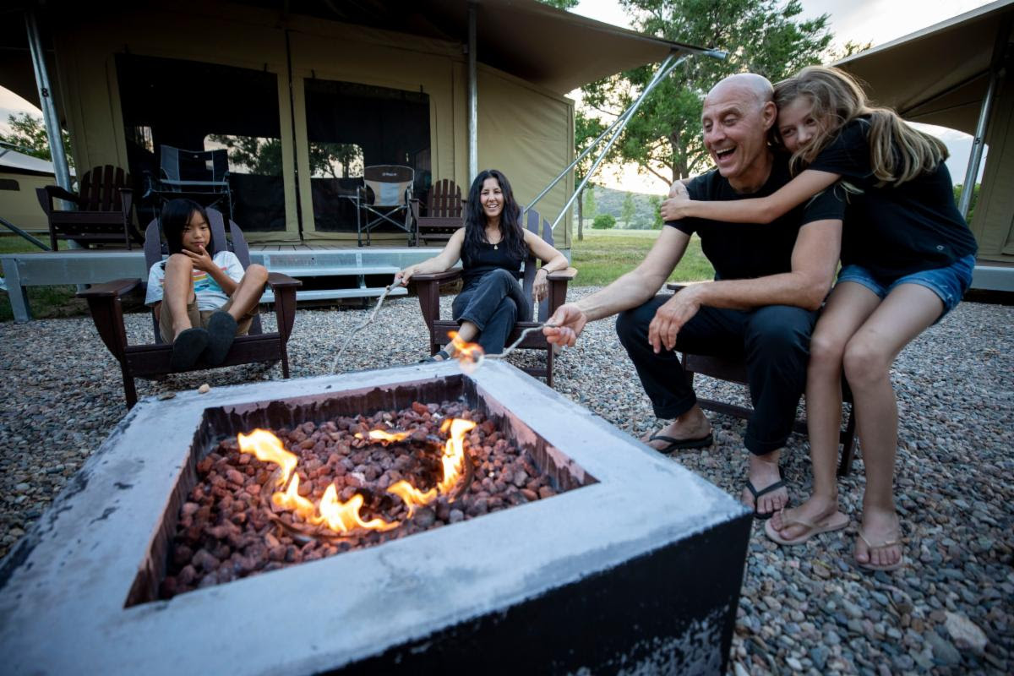

Philmont Training Center now has an option of deluxe tents for those attending conferences or Family Adventure Camp.

