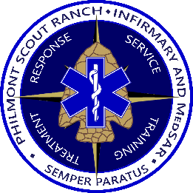

Autism at Philmont
In 2015, scouts with an autism spectrum disorder comprised about one out of every twenty people in Scouting America. Every summer many of these scouts complete a Philmont adventure. Like with any crew, proper training, preparation and communication must take place before arrival to ensure a scout with autism has an enjoyable, safe, and constructive Philmont experience.

Prior to coming to Philmont
A Philmont trek is filled with adventure and uncertainty. For scouts with autism, the uncertainty of a trek may cause unique challenges crews must prepare for. Frequent practice hikes designed to develop a backcountry routine with daily events such times for going to and getting out of bed, meals, and crew reflection will help the transition from the daily home routine to Philmont.

Philmont recommends parents participate alongside their scout with autism on trek. If a parent cannot come to Philmont, then ensure the advisors of the crew are informed of the scout’s unique needs. Such needs include methods for calming the scout, techniques to increase functioning, and triggers that especially agitate the scout. Practice hikes will also help advisors along with other crew members acquaint themselves with your scout’s strengths and needs in a more controlled environment.

Medications
Philmont advises against major changes in medications in the three months prior to and during a trek. Should a scout with autism take any medications such as anxiolytics, antidepressants, sleep aids, or agitation medication for their core symptoms, continue taking them exactly as prescribed. Abruptly discontinuing a medication may cause worsening symptoms. Discuss with your physician during your Philmont medical exam before arriving at Philmont on how hiking at altitude and strenuous activity may affect your scout. If needed, the Philmont infirmary can store backup medications you bring for your scout in case their medication becomes lost or damaged and can deliver these backup medications to your crew in the backcountry.

On the Trail
The first day at Philmont is quite busy as your ranger guides your crew through basecamp procedures. Take a moment after meeting your ranger to communicate with them about your scout’s unique needs, triggers, and learning styles to help them best tailor your crew’s training schedule.

Please feel free to contact the Philmont Infirmary at (575) 376-2281 Ext: 51024 or email Philmont.Infirmary@scouting.org to discuss your specific circumstances or ask any questions.

