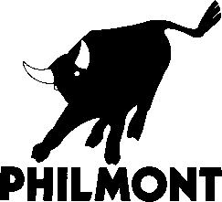
Philmont Scout Ranch, BSA
Fly Fishing Invitational
Reservation Form
Date: Thursday, September 10 thru Sunday, September 13, 2026. Program concludes with
Sunday lunch.
Fee: $625 per person

Name: ___________________________________ Preferred Name: _____________________
_{First} _{MI} _{Last}
Address: _______________________________ Phone: Mobile ______________________
_______________________________ Home _______________________
Email: ________________________________________________________________________
Scouting Role: __________________________________
Fees Enclosed: _____ $250 Non-Refundable Deposit _____ $625 Full Fee
Participant Signature: ___________________________________________________________
Scout Executive Signature: _______________________________________________________
Scout Executive Name: (Print) ____________________________________________________
Council Name: _________________________________________________________________
-------------------------------------------------------------------------------------------------------------------------------
New Mexico requires all fishing licenses to be purchased online. Please follow the steps below to purchase your license. Do this a couple of days prior to your arrival.
Go to the New Mexico game and fish https://www.wildlife.state.nm.us/fishing/licenses-permits.
- You will need the 5-day license. ($24) This will cover the three days you will be fishing.
- Habitat Stamp ($10)
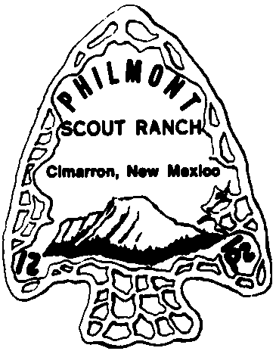
- Habitat Management and Access Validation or HMAV ($4)
- There will also be a vendor charge at the end ($1)
Total = $39.

Please submit your completed forms and deposits by June 15, 2026 to:
Carrie.Hairston@scouting.org Or: Philmont Scout Ranch, BSA
Attn: Fly Fishing Invitational
17 Deer Run Road
Cimarron, NM 87714
(4/16/26 CH)

