NOTE: These are guidelines, NOT a policy. Physicians may alter protocol at their discretion.
- Contact Nate Lay, Infirmary Manager, & Philmont Security to make them aware of the patient.

Patients threatening suicide in the Backcountry:
- Patients should remain on the porch with staff at all times.
  - Youth patients must have 2 adults with them at all times, 1 of which must be Philmont staff.
  - Patients may not walk to the red roof alone.
  - Patients may not have access to knives, rope, power cords, belts or medications.
  - Patients may have a spoon to eat (no knives or forks).
- Separate patients from belongings.
  - Patients may access backpack under direct supervision.
  - “For your safety, we are going to put your things in the staff cabin.”
- Radio call for next available transport to the Infirmary.
- For patient & staff safety, avoid having the patient spend the night in the backcountry if possible.
- Place patients in the middle seat of the vehicle if possible and engage child safety locks on doors.

Patients threatening suicide presenting to the Infirmary:
- Place patients in a quiet room for privacy, confidentiality & safety, ideally in the recliner in the consult room or in inpatient room #1.
  - Remove items from the room that may be used for self-harm.
  - Patients must not wait in the waiting room and should not leave without being seen.
- Separate patients from belongings.
  - “For your safety, we are going to put your things at the nurse’s station.”
  - Patients may access their backpack and belongings under direct supervision.
- While in the Philmont Infirmary:
  - Patients may not have access to knives, rope, belts or medications.
  - Patients may have a spoon to eat (no knives or forks).
- Perform & document physical exam as well as mental health/psychiatric exam.
- Perform COLUMBIA Screening tool. Document YES answers in EMR.
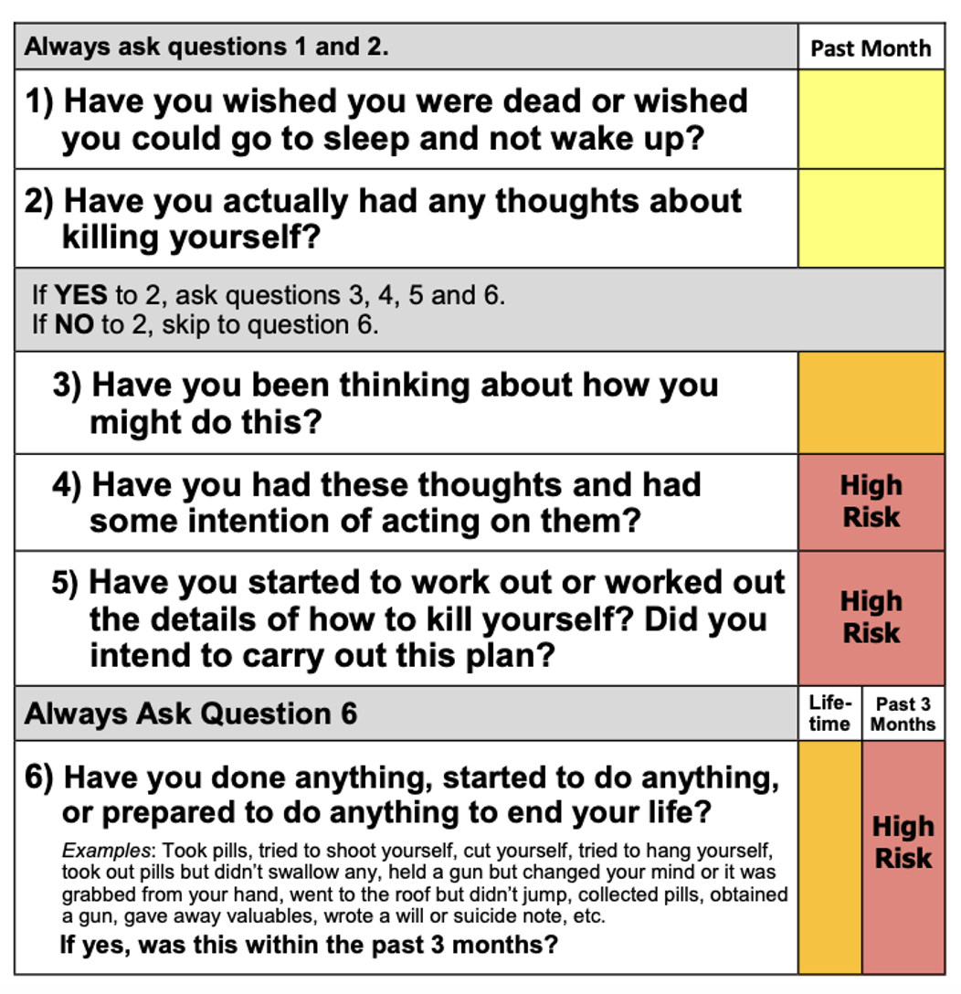
- Immediately transport to the ER:
  - ACTIVELY Suicidal patients “I want to kill myself”
    - YES to Columbia questions 4, 5 or 6
    - Any patient with suspected overdose
  - Patient that intends to harm others
  - Patient having command auditory hallucinations
NOTE: Philmont has limited services and we cannot keep patients intending to harm themselves or others safe here at Philmont.

- PASSIVELY suicidal “I want to go to sleep and not wake up”
  - YES to Columbia questions 1, 2 or 3
  - If patient is a participant, call parents to initiate pick up ASAP.
  - If staff, consult in house psychology or offer next available transport to ER for evaluation.
  - Offer to have a Chaplain visit if the patient desires.
  - Attempt to Mental Health Safety Plan patients.
  - Arrange inpatient bed in infirmary.
    - Patient may have belongings except no belts, power cords, knives, or meds
    - No utensils other than spoons.
  - Have 2nd Medic sleep in infirmary.

- If a suicidal patient wants to leave, notify security to track the patient’s location on our grounds.
  - Do NOT detain them. Call Nate Lay & law enforcement if you have reason to believe the patient presents a likelihood of serious harm to themselves or others.

- Any patient that is a danger to others or psychotic/hallucinating should be transferred to the ER.

Patient Returning to the Infirmary from the ER:

- No return to backcountry. Only patients with stable medical or mental health conditions may trek or work in the backcountry. “Clearance” or discharge from the ER or mental health services does not mean the patient is appropriate for the rigors of Philmont. If a patient has been suicidal or psychotic (hearing voices) in the last 3 months, they are high risk and not stable to return to trek or work in the backcountry.
  - If patient is a participant, notify Infirmary Manager to call parents to initiate pick up ASAP.
  - If patient is staff, consult Nate Lay regarding disposition.
  - Consult in house psychology if available.
  - Offer chaplain if patient desires.
  - Arrange inpatient bed in infirmary with same restrictions in 7.f.i and 7.f.ii

Mental health services at Philmont and in Cimarron (Colfax County) are scarce.
Due to this, most participants and staff would be better served at their home.

